# Question 01

## Code

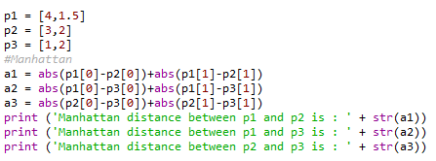

## Output



# Question 02

## Code

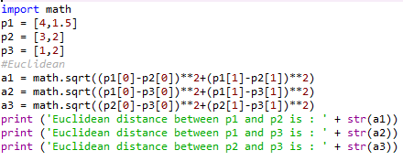

## Output



# Question 03

|  |  |  |  |
| --- | --- | --- | --- |
|  | A1 | A2 | L |
| D1 | 2 | 2 | X |
| D2 | 1 | 3 | X |
| D3 | 4 | 3 | O |
| D4 | 5 | 4 | O |

Test point =[3 ,3]

Find label?

## A

Find the distance between test point to all other points

Distance 1=√(2-3)2 + (2-3)2=1.41

Distance 2=√(1-3)2 + (3-3)2=2

Distance 3=√(4-3)2 + (3-3)2=1

Distance 4=√(5-3)2 + (4-3)2=2.23

For 1NN means K=1 and the smallest distance is 1 and label assign is o.

## B

For the k=2 we have point (4,3) and (2,2) are nearest point.

So 1 point is label with o and second point label with x.

## C

For k =3

(4,3) is label with o

(1,3) is label with x

(2,2) is label with x

So maximum label is x.

### Results

|  |  |  |  |
| --- | --- | --- | --- |
| 1NN | 3 | 3 | o |
| 2NN | 3 | 3 | o/x any |
| 3NN | 3 | 3 | x |

# Question 04

|  |  |  |  |
| --- | --- | --- | --- |
|  | A1 | A2 | L |
| D1 | 2 | 2 | X |
| D2 | 1 | 3 | X |
| D3 | 4 | 3 | O |
| D4 | 5 | 4 | O |

Test point =[4 ,1.5]

Find label?

## A

Find the distance between test point to all other points

Distance 1=√(2-4)2 + (2-1.5)2= 2.0616

Distance 2=√(1-4)2 + (3-1.5)2= 3.3541

Distance 3=√(4-4)2 + (3-1.5)2=1.5

Distance 4=√(5-4)2 + (4-1.5)2= 2.6926

For 1NN means K=1 and the smallest distance is 1.5 at (4,3) and label assign is o.

## B

For the k=2 we have point (4,3) and (2,2) are nearest point.

(4,3) is label with o

(2,2) is label with x

## C

For k =3

(4,3) is label with o

(2,2) is label with x

(5,4) is label with o

So maximum label is o.

### Results

|  |  |  |  |
| --- | --- | --- | --- |
| 1NN | 3 | 3 | o |
| 2NN | 3 | 3 | o/x any |
| 3NN | 3 | 3 | 0 |

# Question 05

## Code

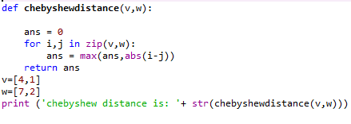

## Output

